Taking a Fresh Look at Your Library!
Presented by Vickie Saltzer, Gettysburg Area High School Librarian
vsaltzer@gettysburg.k12.pa.us

Five Laws of Librarianship (Raganathan, 1931)
- Books are for use
- Every reader his [or her] book
- Every book its reader
- Save the time of the user
- The library is a growing organism

“Every school library must start moving down a path to enrich its students’ learning experience. Mutation will occur on the path; no two cocoons will produce the same butterfly. Your job is to make sure whatever you hatch for your district supports student learning.” Margaret L. Sullivan, 2015.

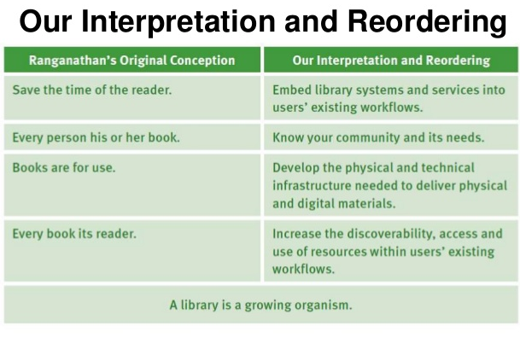

Sources:
- Connaway, Lynn Silipigni, and Ixchel M. Faniel. Reordering Ranganathan: Shifting User Behaviors, Shifting Priorities. Dublin, OH: OCLC Research, 2014. Print.
- Sullivan, Margaret L. High Impact School Library Spaces: Envisioning New School Library Concepts. Santa Barbara, CA: Libraries Unlimited, 2015. Print.

